BookSim2 User Note

Methodology

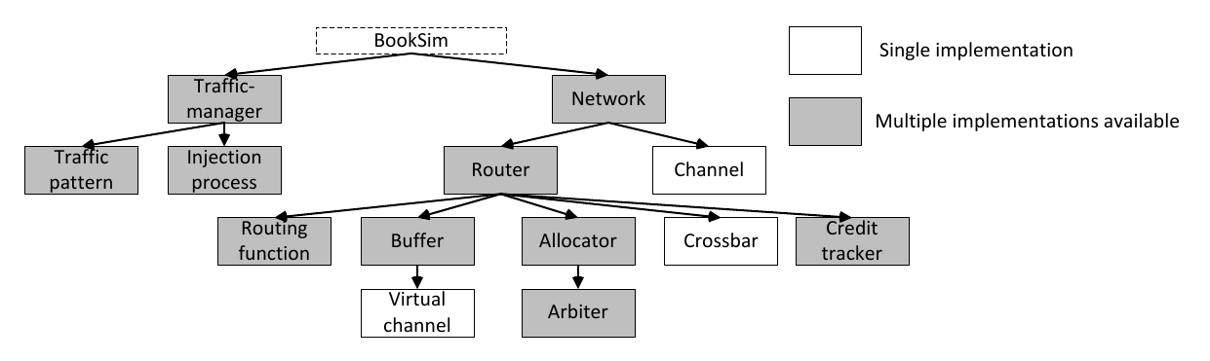

Top level

## Traffic-manager

It **injects packets into the network** according to the **user-specified configuration**, including the traffic pattern, packet size, injection rate, etc. To properly model network behavior beyond the point of saturation in open-loop simulations, an infinite **source queue1** is implemented at the injection nodes to ensure that latency measurements properly account for source queuing delay and head-of-line blocking effects. The traffic-manager is also responsible for e**jecting packets** from the destination endpoints, collecting appropriate **statistics**, and **terminating the simulation**.

Publich function:

static TrafficManager * **New**(Configuration const & config, vector<Network *> const & net);

To generate a new traffic-manager object.

bool **Run**( );

Running the simulation with statistics.

## Traffic-Pattern

There are 21 kinds of traffic patterns provided by the simulation.

## Injection-process

Configuration:

**injection_rate** = 0.25: means that each source injects a new **packet** in one out of every four simulator cycles.

**injection_rate_uses_flits** = 1 if you want use flit-level granularity injection.

**injection_process** = bernoulli or on_off

Compile: